Form 4 Name:
Listening Comprehension
Term 2
Variant I
Task 1. Listen to the text and tick () the correct pictures.
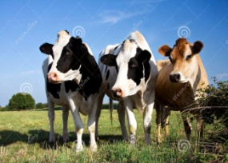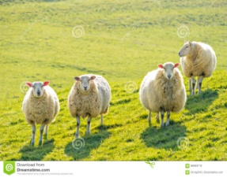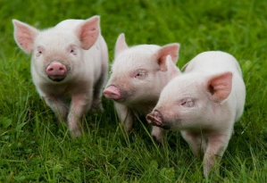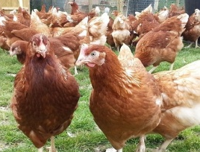
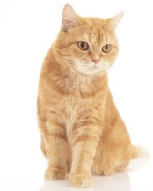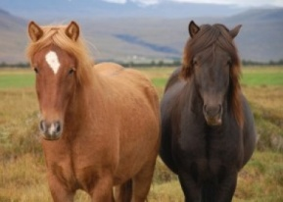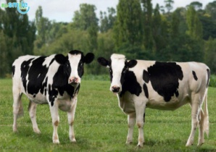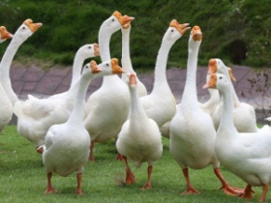
Task 2. Listen to the text. Mark the sentences True or False.
1. | Lilly has got a big flat in the city.
2. | Lilly has got two cows.
3. | Their chickens don't give eggs.
4. | They plant fruit and vegetables in their vegetable garden.
5. | Lilly helps her parents on their farm.

Task 3. Complete the sentences.
eggs, pigs, chicken, farm, geese

1. Lilly has got a lot of animals on the ___________________________________.
2. Lilly has got two cows, four sheep and three ___________________________.
3. In the chicken house Lilly has got ________________ and_________________.
4. Lilly's mum cooks ________________________________________ for breakfast.

Mark:
Form 4 Name:
Listening Comprehension
Term 2
Variant II
Task 1. Listen to the text and tick () the correct pictures.
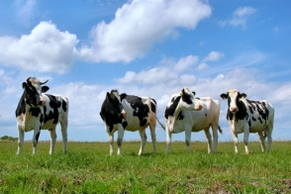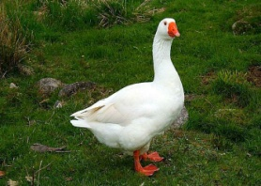
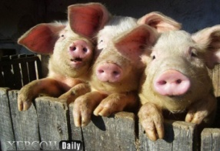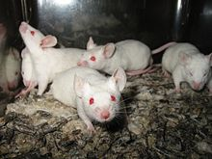

Task 2. Listen to the text. Mark the sentences True or False.
1. | Lilly has got a farmhouse in the country.
2. | Lilly has got four pigs.
3. | Their chickens give milk.
4. | They plant cabbage, potatoes and carrots in their vegetable garden.
5. | Lilly doesn't help her parents on their farm.

Task 3. Complete the sentences.
cows, eggs, vegetables, sheep, country

1. Lilly and her family live in the __________________________________________.
2. Lilly has got two ___________________, four ________________ and three pigs.
3. Chicken give _________________________________________________________.
4.They have a lot of ____________________________ in their vegetable garden.

Mark:
Our farmhouse
My name is Lilly. My family and I live in the country. We have a farmhouse. We have got a lot of animals on our farm.
We've got two cows. They give a lot of milk. We also have got four sheep and three pigs. They are nice and funny.
Our chicken house is very big. There are a lot of chickens and some geese. The chickens give eggs. My mum cooks them for breakfast in the morning.
In our vegetable garden there are a lot of vegetables. We plant cabbage, potatoes and carrots.
I help my parents to look after the animals.

